**EXERCISE 4 – MULTIPLE INHERITANCE**

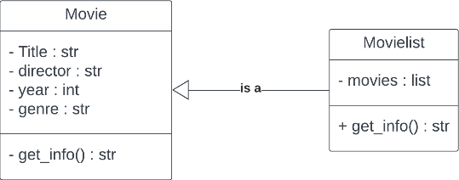**CLASS DIAGRAM – EX 4.1**

**CLASS DIAGRAM – EX 4.2**

**CLASS DIAGRAM – EX 4.3**

**PACKAGE DIAGRAM**

